7.3 Frame

The frame must be able to support the weight of the rider, outer shell, and interior components. With all the weight on the frame the wheel placement plays an important role. The frame of the bike must be designed in such a way that the rider is always safe. The bike must not tip ~~of~~ or flip over in anyway. Also the rider must be able to maintain visibility and handling in any situations. To make sure that the bike is the safest it can be two engineering principles were examined. The first principle was *force distribution,* within force distribution two aspects were looked at, both wheel and seat placement. The second principle *is centre of mass*, which was determined by the height of the seat off of the ground.

7.3.1 Force distribution

* + - 1. Wheel placement

Wheel placement will be determined based on the length of the *wheel base*. A wheel base that is too long will result in the bike to have reduced handling. It will also cause the bike to have a greater *turning radius*. The long wheel base will result in the most unstable bike, the longer the wheel base the easier it is for the bike to tip over ~~or become~~ or roll. On the positive side a long wheel base provides a more comfortable and smooth ride since the rider is further away from the wheels. Figure 1 is an example of a recumbent bike with a long wheel base, although the bike in the figure is not a tricycle it depicts what a long wheel base may look like.

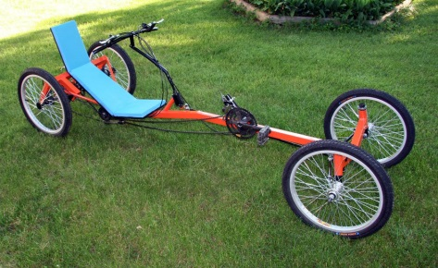

Figure 1: Long Wheel Base [1]

The short wheel base leads to a sturdier bike with better handling, and a smaller turning radius. The rider is almost on top of the front wheels with a short wheel base resulting in a bumpier and uncomfortable ride. Also, since the rider is almost on top of the front wheels, the rear wheel will not have enough weight on it. A lack of weight on the rear tire will cause the tire to not gain enough *traction* and spin out, or the rider could flip forward when applying the brakes. Look at figure 2 for an example of a short wheel base.

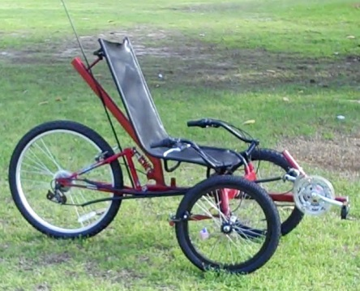

Figure 2: Short Wheel Base [2]

Therefore the ideal wheel base is 100 cm [3]. This distance is chosen to ensure maximum comfort, handling, and safety.

* + - 1. Seat placement

Where the seat is placed is also a big factor in force distribution as the rider may be very heavy and is directly on top of the frame A seat that is too close to the rear tires can result in the bike flipping backwards while riding, a seat too close to the front tires could also cause the bike to flip forward when braking. If the seat is too close to either tire the rider could be uncomfortable. If the seat is too close to the rear the bike will be less sturdy and could tip easier. The best seat placement is the ratio of 70/30 measured front tires to back tire [4]. That is 70 % of the distance towards the front tires if measuring the wheel base starting at the back tire, or based on the wheel base length of 100cm the seat will be 70 cm from the rear tire towards the front. Since the number can vary slightly, and is just the most ideal placement, the seat will be able to slide forward and backwards to tailor to the riders comfort, which can be examined more in the interior section. An example of the ideal seat placement can be seen in figure 3.

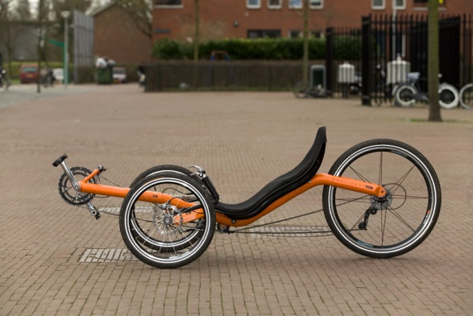

Figure 3: Seat Placement [5]

* + 1. Centre of Mass

The centre of mass plays a very important role in how sturdy the bike is. If the centre of mass is low enough the bike is very unlikely ~~the bike will~~ to tip, regardless of wheel and seat placement. A centre of mass that is too low can result in a decrease in visibility and safety. Since centre of mass ~~if~~ is dependent of the seat height off of the ground the frame must be lowered or lifted in order to have an ideal centre of mass. If the wheel base length and seat placement are not ideal the centre of mass should be below the centre of the tires, but high enough to maintain visibility. Since the wheel base if the ideal length and the seat is in the ideal place the centre of mass can be an equal height of the centre of the tires from the ground and not cause the bike to become unsteady. This can be achieved by putting a bend or curve in the frame within the wheel base. Figure 4 shows a bike with a higher than ideal centre of mass since the frame does not bend or dip down enough to ensure the seat is in line with the centre of the wheels.

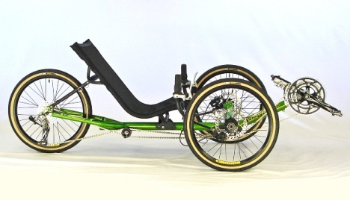

Figure 4: High Centre of Mass

The bike is going to have a seat suspension system, and the shocks will be around 14 cm in length. This mean that the frame needs to be lower than the centre of the wheel by 14 cm, which can work since the average wheel radius, is around 33 cm.

* + 1. Conclusion

The ideal frame for the bike is one that is sturdy, safe, has good visibility and handling. The force distribution of the bike relies on both wheel and seat placement. The wheel base length is 100cm long and the seat will be placed 30 cm measured from the rear tire towards the front. The centre of mass mostly relies on how high the seat is off of the ground. Since the wheel and seat placement are ideal the seat will be in line with the centre of the wheels. With these three placements the bike should be safe and handle with ease. An example of a bike with these conditions can be seen in figure 5.

FIGURE 5 TO BE INCLUDED HERE